**Works notice – Flemington housing site**

**September 2024**

Piling to commence Friday 4 October 2024

Homes Victoria, together with project partner Building Communities, is redeveloping the Holland Court, Flemington housing site to provide 286 social and affordable rental homes that are modern, accessible and sustainable as well as a large new public park. The builder at the site is ICON.

**Piling works**

To prepare the Holland Court site for new homes, piling rigs will arrive at the site via a truck escort on Holland Court early in the morning on **Friday 4 October**.

A section of the footpath will also be closed on Holland Court. Traffic management will be in place to direct vehicles and pedestrians while this work occurs. Please refer to the map over the page for details.

Piling rigs are large machines used in construction to create deep foundations for buildings and structures. They drill into the ground and insert concrete piles to support the weight of the future buildings.

Once the piling rigs are in place, piling will commence on **Friday 4 October** and continue through to mid-December. There will be noise while these works occur. We apologise for the inconvenience.

**ICON has a 24-hour hotline and email for residents**

We know that living near a construction site is not easy and we want to thank residents in Flemington for their understanding while we continue to revitalise the Flemington housing site.

If you have any questions or concerns about the Holland Court, Flemington housing project, please contact ICON’s 24-hour resident hotline on **(03) 9389 3619** or email [**community.questions@icon.co**](mailto:community.questions@icon.co)

**Map showing piling rig access to Flemington housing site**

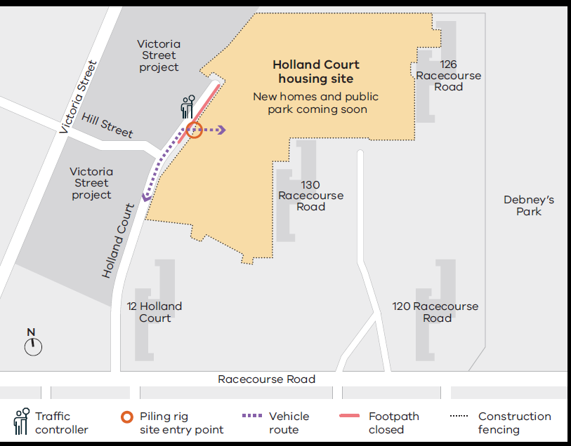

Need an accessible or interpreted version of this project update? If you would like to receive this publication in an accessible or interpreted format, please call 1300 650 172 or email 
enquiries@homes.vic.gov.au

**Further information**

For more information about the Holland Court, Flemington housing project, please visit: [**www.homes.vic.gov.au/holland-court-flemington**](http://www.homes.vic.gov.au/holland-court-flemington)

Authorised and published by the Victorian Government, 1 Treasury Place, Melbourne. © State of Victoria, Australia, Homes Victoria, September 2024.