**Works notice – Flemington housing site**

**August 2024**

Changes to car parking from Thursday 19 September 2024

Homes Victoria, together with project partner Building Communities, is redeveloping the Holland Court, Flemington housing site to provide 286 social and affordable rental homes that are modern, accessible, and sustainable as well as a large new public park. The builder at the site is ICON.

From **Thursday, 19 September 2024**:

* The small carparking area next to Holland Court will be closed off and site fencing installed.
* A new carparking area providing more spaces for residents will be opened next to the carpark facing Racecourse Road and next to 12 Holland Court.

Please see the map over the page for details.

**YOU ARE REQUIRED TO MOVE YOUR VEHICLE**

**By Wednesday 18 September, please move your vehicle from the car park that is closing. Any vehicles that are not removed or that are not registered with VicRoads will be towed.**

**ICON has a 24-hour hotline and email for residents**

We know that living near a construction site is not easy and we want to thank residents in Flemington for their understanding while we continue to revitalise the Flemington housing site.

If you have any questions or concerns about the Holland Court, Flemington housing project, please contact ICON’s 24-hour resident hotline on **(03) 9389 3619** or email [**community.questions@icon.co**](mailto:community.questions@icon.co).

**Map showing car parking changes at Flemington housing site**

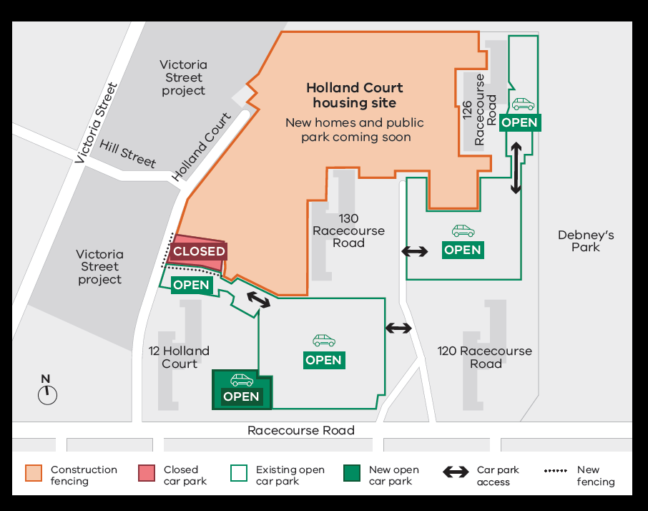

Need an accessible or interpreted version of this project update? If you would like to receive this publication in an accessible or interpreted format, please call 1300 650 172 or email 
enquiries@homes.vic.gov.au

Further information

For more information about the Holland Court, Flemington housing project, please visit: [**www.homes.vic.gov.au/holland-court-flemington**](http://www.homes.vic.gov.au/holland-court-flemington)

Authorised and published by the Victorian Government, 1 Treasury Place, Melbourne. © State of Victoria, Australia, Homes Victoria, August 2024.